The Great Lesson of Dispensational Teaching – Rob Madden
2 Timothy 2:15 - Study to shew thyself approved unto God, a workman that needeth not to be ashamed, rightly dividing the word of truth.
2 Timothy 3:15-17 - And that from a child thou hast known the holy scriptures, which are able to make thee wise unto salvation through faith which is in Christ Jesus.
All scripture is given by inspiration of God, and is profitable for doctrine, for reproof, for correction, for instruction in righteousness:
That the man of God may be perfect, throughly furnished unto all good works.
Understanding Dispensations Enables the Believer to “rightly divide” the Holy Bible (2 Tim 2:15) and to properly Apply any Portion of It (a word, a phrase, a verse, a passage, a chapter, or a Book) to Himself (2 Tim 3:15-17):
1. For salvation (v.15).
2. For inspiration (v.16).
3. For indoctrination (v.16).
4. For reproof (admonition) (v.16).
5. For correction (v.16).
6. For instruction (v.16).
7. For preparation (v.17).

Of the many things God has showed man through the dispensations, the lesson that should stand out above the others is that man is a hopeless rebel, utter failure, and without hope without God. He is simply not capable of living up to God's righteous standard no matter how "enlightened" and able he may think he is.
• Place him in a beautiful garden with everything he needs, including fellowship with God, a beautiful and compatible wife, the earth under his dominion, access to the Tree of Life, etc., and man will forsake it all and choose death.
• Leave him alone with his conscience to guide him and man will become so exceedingly wicked that he must be removed from the earth with a flood.
• Give him great and sure promises and man will flee them and speak lies in unbelieving fear.
• Make of him a chosen nation for God to speak through and dwell among, with His holy Law and priesthood, and man will abandon his God and worship dumb idols.
• Give him an eternal redemption from sin and hell, everlasting life, an indwelling Holy Spirit, the promise of a new body, a home in New Jerusalem, and birth him into God's own family making him His son, and man will repay his Savior with rebellion, worldliness, and indifference.
• Give him a perfect, uncursed earth, a cooperative environment, no Satan to tempt him, extended lifespan, and Jesus Christ himself to reign over him, and man will revolt and try to force Christ from His throne.
All is clear… Man is a wicked, vile, evil, selfish, and vain creature, and apart from God he is utterly hopeless and bound for hell. The surest proof of this is God is near the last millennium of his dealings with man (now 6000 years along), and man collectively has not learned this ONE lesson yet!
The Bible teaching concerning the Spirit may be divided into three general divisions: (1) The Spirit according to the Old Testament; (2) The Spirit according to the Gospels and as far in the Scriptures as The Acts 10:43; (3) The Spirit according to the remainder of The Acts and the Epistles.
Dispensational Chart
Understanding The Bible
In Eph. 2 the Apostle Paul sets forth the basic three-fold division in God’s dealings with mankind: Time Past (v.11,12), But Now (v.13), and The Ages to Come (v.7). When the Bible is “laid out” according to this divinely inspired design we easily get an overview of not only what we are reading but when and to whom it was written.
Ephesians Chapter 2
Thus the Word of God itself provides us with the key to its own proper understanding and right division: See the definitions of each at the bottom of this page.
The below chart in two parts demonstrates the importance of the secret, hidden nature of the present dispensation of grace (Eph. 3:1-9). See the first part of the chart to hide the “mystery” section and you will see the perfect continuity of that “which God hath spoken by the mouth of all His holy prophets since the world began” (Acts 3:21). See the second part of the chart to reveal the mystery program and you will visualize how the prophetic program has been temporarily interrupted by “the revelation of the mystery, which was kept secret since the world began, But now is made manifest” (Rom. 16:25,26)
Ephesians Chapter 1
22 And hath put all things under his feet, and gave him to be the head over all things to the church, 23 Which is his body, the fulness of him that filleth all in all.
ILLUS.
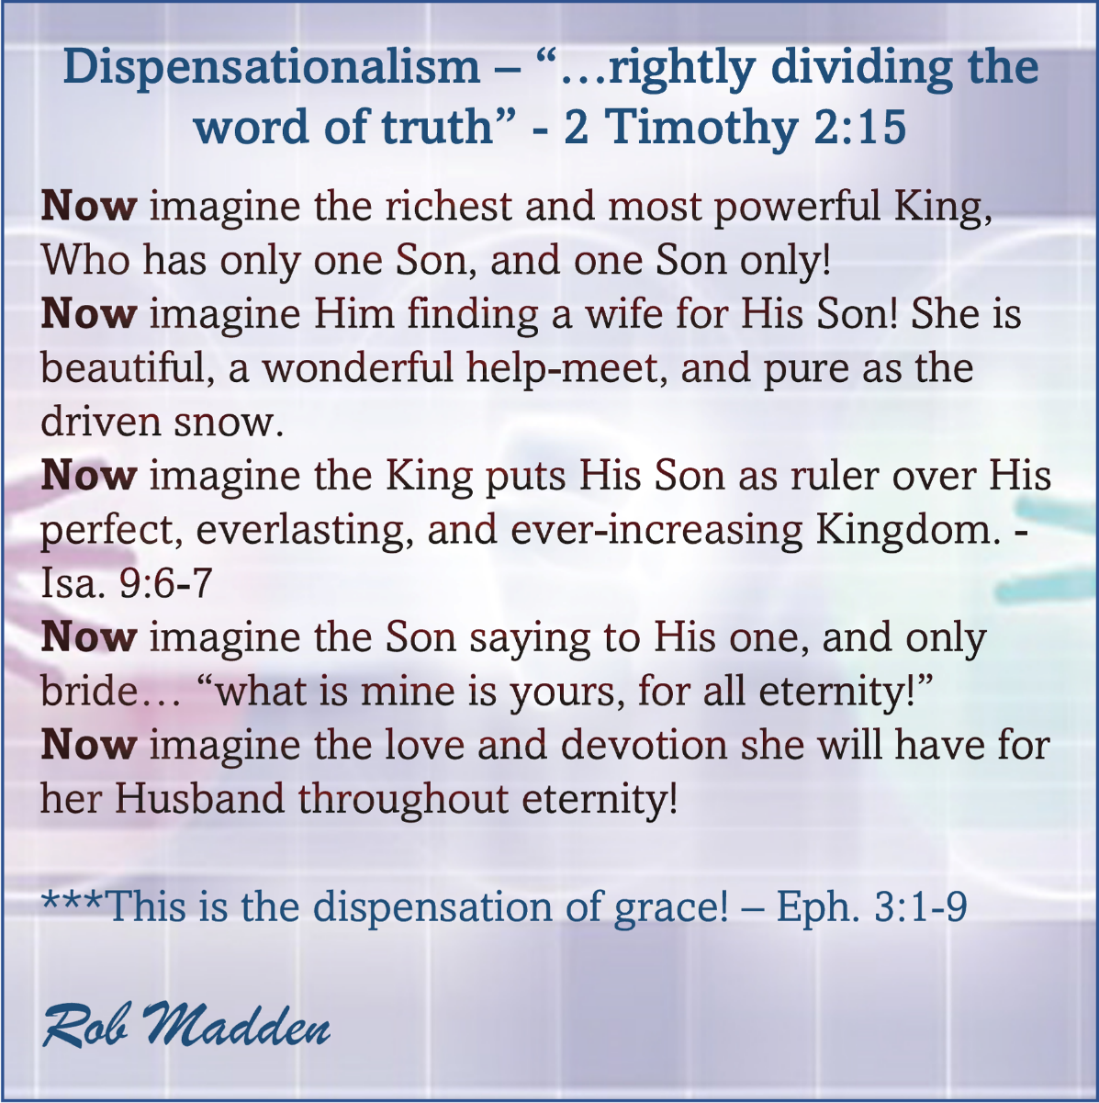
NOTE: Thanks to the many scholars that this study was gleaned from!

