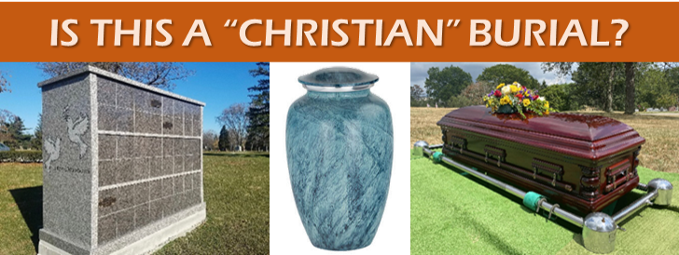
Dr. Paul Fedena
People speak of a “Christian Burial”. What exactly is that? Is there such a thing in the Bible? If we use Jesus’ death and burial, we will have to be buried above ground in a tomb. (The same with Lazarus, and I have been inside what is supposed to be his tomb in Israel.) You can be buried in an above ground tomb OR “vault” in many cemeteries here in America too if that is your preference. It seems that many O.T. saints were also buried in tombs, not underground.
Cremation is often frowned upon or argued against, but it is increasingly popular in America today. Is it “unbiblical”? Many pagan religions practice cremation, but does that rule it out for believers? Obviously, the dear Holy Spirit is no longer indwelling a lifeless body. There is a wide variety of opinions even among pastors and Bible believers concerning this subject.
As a pastor I have had many funerals and of course that means I have had experiences with funeral homes and those who are employed there. I have sat with church members as they met with funeral directors and heard discussions about burial plots, witnessed the sales techniques and how loved ones are carefully nudged to purchase coffins (with “soft and comfortable posture-pedic mattresses”, etc.), vaults, flowers, rent for a hearse and a family car, select expensive caskets with all kinds of beautiful adornments or made of expensive materials (beautiful wood finishes, shining metals, etc.) Then there is the grave site, cemetery fees, etc. Everything comes with a price tag of course. Usually, the deceased had some kind of insurance policy which covers some, most, or all of the expenses, which was supposed to go to the loved one(s) left behind. Then there is the expense of the grave diggers, the plot for burial, the cemetery fee, a charge for the cemetery chapel, if used, etc.
[The average cost of a funeral in Pennsylvania typically costs between $7,000 and $12,000. It can be much higher. You will pay for viewings, service fees, transportation, caskets, embalming, and other preparation costs (including makeup, hairdressing, dressing the body, etc.) as part of this price. I have heard people remark “doesn’t he (or she) look nice?” Maybe I will look a little better when dead after the makeup artist is through with me, than I look now!]
I cannot forget a dear mentally handicapped young lady who was left in charge of her mother’s funeral, and the conversation with the funeral director (or his employee) and how he tried to manipulate this young woman’s choices of a casket, etc. Finally, I asked him to leave her and myself alone. I knew of her pitiful financial circumstances and did not want her to be coerced into making expensive choices. With my help she finally chose the least inexpensive casket. On the way from the expensive hearse to the grave site, as I walked with the funeral director, he remarked “I hope the bottom doesn’t fall out of that casket before we get to the grave.” (It looked like it was constructed of paper mâché.)
What is the purpose of visiting a gravesite? There is really no one there. The deceased is either in heaven or hell, not in any grave. (Job said in 19:26 And though after my skin worms destroy this body, yet in my flesh shall I see God.”) He or she will certainly not smell the flowers you may leave there.
Increasingly popular is a simple memorial service where the loved one is tenderly remembered by family and friends. (The body of the deceased has probably been cremated, and there may be an urn present that contains his or her ashes.) A memorial service doesn’t require all the accoutrements of a traditional American funeral. It does give family and friends an opportunity to remember the deceased person and his or her traits, quirks, etc. and maybe someone will even relate a humorous incident, etc. and the message may even result in someone coming to receive Christ as their Savior.
Another possible choice is to will your entire body for medical research in the hope that you may help someone else even after you are no longer on earth. When my beloved wife, who was a wonderful wife, helpmeet and special pastor’s wife went to heaven, (I miss her every day!) The facility was contacted, and they took her lifeless form from the hospice to their lab and about four months later I got a call and the person there informed me that they were able to use four of her organs to help those on waiting lists. I thought ‘wouldn’t it be great if one or more of those people got saved and I and my wife would see them again in heaven?’ (Total cost? $0!)
My family knows that is also my personal choice. Whatever I leave behind will be divided equally among them (except of course what the Government declares “belongs” to them?!).
In this paper, I am not trying to influence your decisions. I realize that many people have strong opinions about these things. I am simply trying to be helpful and practical and ask you to think clearly and as unemotionally as possible and to let those you may leave behind be informed, so they can follow your wishes.
To not leave anyone in the family, etc. in the dark, it is best to put your wishes in writing.

