BOOKS YOU MUST READ
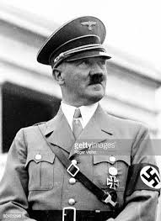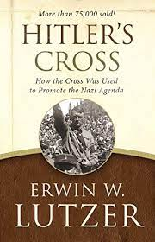

A few years ago, a famous and influential preacher purchased a book for me to read. I didn’t understand why he recommended it, even though I was a World War 2 buff. In fact, I don’t think he knew that at the time.

It was called *“HITLER’S CROSS” – by Irwin Lutzer (pastor of the famous Moody Church for 36 years and writer and broadcaster)

I read the book and followed the narrative with great interest. However, I still couldn’t figure out why this preacher recommended it to me. Several years later, I re-read the book and suddenly the light went on. It became obvious that this man of God had discovered that Hitler’s agenda in turning a nation into a man-worshipping country and himself into a god and the country of Germany into a fanatical one party system of government and an absolute socialistic state (The National Socialist German Workers Party), and that the dramatic steps taken to accomplish this is exactly the way America has been going in the last couple of decades and into the present.

Since then, he followed up with a sequel entitled “WHEN A NATION FORGETS GOD”, Erwin Lutzer studies seven similarities between Nazi Germany and America today—some of them chilling—and cautions us to respond accordingly. Engaging, well-researched, and easy to understand, Lutzer’s writing is that of a realist, one alarmed but unafraid. Amidst describing the messes of our nation’s government, economy, legal pitfalls, propaganda, and more, Lutzer points to the God who always has a plan.
At the beginning of the twentieth Century, Nazi Germany didn’t look like a country on the brink of world-shaking terrors. It looked like America today. When a Nation Forgets God uses history to warn us of a future that none of us wants to see. It urges us to be ordinary heroes who speak up and take action. Dr. David Jeremiah said that he would, if he could, place this book in the hands of every Christian in our nation.

Is it possible that America will become a one-party system of socialism like Nazi Germany did? Will the next election be rigged like the last one in 2020? Will we ever have a fair election system again? In fact Pres. Biden is presently on a no holds barred attempt to rewrite our election system right now and is even attempting to shut off all opposition by changing the governments rules regarding filibustering. In other words to stop any and all arguments to the contrary.

I urge you to order both of these books on Amazon Kindle or in hardback wherever you shop for books.

*Hitler's Cross: The Revealing Story of How the Cross of Christ Was Used as symbol of the Nazi agenda

